A project report on
ENHANCE THE CENTRAL NAVIGATION TRACKING ROBOT USING CAMERA
Submitted in partial fulfilments of the requirements for the awards of the
Degree Of
BACHELOR OF TECHNOLOGY
In
ELECTRONICS AND COMMUNICATION ENGINEERING
By

ENHANCE THE CENTRAL NAVIGATION TRACKING
ROBOT USING CAMERA

Introduction
Robotics is an interdisciplinary branch of computer science and engineering. Robotics involves design, construction, operation, and use of robots. The goal of robotics is to design machines that can help and assist humans. Robotics integrate fields of mechanical engineering, electrical engineering, informationengineering, mechatronics, electronics, bioengineering, computer engineering, control engineering, software engineering, mathematics, etc.
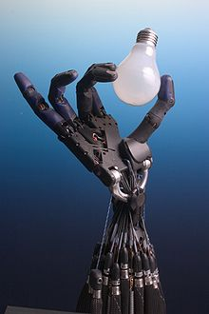
The Shadow robot hand system
Robotics develops machines that can substitute for humans and replicate human actions. Robots can be used in many situations for many purposes, but today many are used in dangerous environments (including inspection of radioactive materials, bomb detection and deactivation), manufacturing processes, or where humans cannot survive (e.g. in space, underwater, in high heat, and clean up and containment of hazardous materials and radiation). Robots can take on any form, but some are made to resemble humans in appearance. This is claimed to help in the acceptance of robots in certain replicative behaviors which are usually performed by people. Such robots attempt to replicate walking, lifting, speech, cognition, or any other human activity. Many of today's robots are inspired by nature, contributing to the field of bio-inspired robotics.
Certain robots require user input to operate while other robots function autonomously. The concept of creating robots that can operate autonomously dates back to classical times, but research into the functionality and potential uses of robots did not grow substantially until the 20th century. Throughout history, it has been frequently assumed by various scholars, inventors, engineers, and technicians that robots will one day be able to mimic human behavior and manage tasks in a human-like fashion. Today, robotics is a rapidly growing field, as technological advances continue; researching, designing, and building new robots serve various practical purposes, whether domestically, commercially, or militarily. Many robots are built to do jobs that are hazardous to people, such as defusing bombs, finding survivors in unstable ruins, and exploring mines and shipwrecks. Robotics is also used in STEM (science, technology, engineering, and mathematics) as a teaching aid.

History

Robotic aspectsEdit
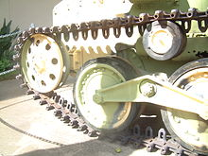
Mechanical construction
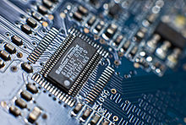
Electrical aspect
There are many types of robots; they are used in many different environments and for many different uses. Although being very diverse in application and form, they all share three basic similarities when it comes to their construction:
- Robots all have some kind of mechanical construction, a frame, form or shape designed to achieve a particular task. For example, a robot designed to travel across heavy dirt or mud, might use caterpillar tracks. The mechanical aspect is mostly the creator's solution to completing the assigned task and dealing with the physics of the environment around it. Form follows function.
- Robots have electrical components that power and control the machinery. For example, the robot with caterpillar tracks would need some kind of power to move the tracker treads. That power comes in the form of electricity, which will have to travel through a wire and originate from a battery, a basic electrical circuit. Even petrol powered machines that get their power mainly from petrol still require an electric current to start the combustion process which is why most petrol powered machines like cars, have batteries. The electrical aspect of robots is used for movement (through motors), sensing (where electrical signals are used to measure things like heat, sound, position, and energy status) and operation (robots need some level of electrical energy supplied to their motors and sensors in order to activate and perform basic operations)
- All robots contain some level of computer programming code. A program is how a robot decides when or how to do something. In the caterpillar track example, a robot that needs to move across a muddy road may have the correct mechanical construction and receive the correct amount of power from its battery, but would not go anywhere without a program telling it to move. Programs are the core essence of a robot, it could have excellent mechanical and electrical construction, but if its program is poorly constructed its performance will be very poor (or it may not perform at all). There are three different types of robotic programs: remote control, artificial intelligence and hybrid. A robot with remote control programming has a preexisting set of commands that it will only perform if and when it receives a signal from a control source, typically a human being with a remote control. It is perhaps more appropriate to view devices controlled primarily by human commands as falling in the discipline of automation rather than robotics. Robots that use artificial intelligence interact with their environment on their own without a control source, and can determine reactions to objects and problems they encounter using their preexisting programming. Hybrid is a form of programming that incorporates both AI and RC functions in them.

Applications

As more and more robots are designed for specific tasks, this method of classification becomes more relevant. For example, many robots are designed for assembly work, which may not be readily adaptable for other applications. They are termed as "assembly robots". For seam welding, some suppliers provide complete welding systems with the robot i.e. the welding equipment along with other material handling facilities like turntables, etc. as an integrated unit. Such an integrated robotic system is called a "welding robot" even though its discrete manipulator unit could be adapted to a variety of tasks. Some robots are specifically designed for heavy load manipulation, and are labeled as "heavy-duty robots.

Abstract
Robotics has been acknowledged as a mainstay in the industrial automation domains. It is gradually making in the headway into the domains of military, medical, and vehicle applications. The navigation of tracking the robot using Arduino used to delivering the objects form source to destination in quickly with in the effective manner with most accurately without using the sensors. The camera is continuously monitoring the robot and assigning the path based upon the software instructions. These robots are moving different paths carry the load form one place to another place. These automated robots perform multiple tasks in simultaneously and reduce the human mistakes. These robots are implemented in the malls, military, museums, hospitalization and industrial applications. The automation and robotics to help bring down costs and deliver goods to destinations at the fastest speed possible.

Problem Statement

Line following robot

Applications

Project Working

Block diagram

Hardware Requirements
- Arduino
- Logic Tech Webcam
- Servo Motor
- Battery
- Gear Motors

Software Requirements
- Arduino IDE Compiler
- Python Programming Language

Components Brief Description

ARDUINO UNO

Arduino is common term for a software company, project, and user community that designs and manufactures computer open-source hardware, open-source software, and microcontroller-based kits for building digital devices and interactive objects that can sense and control physical devices.^{[1]}
The project is based on microcontroller board designs, produced by several vendors, using various microcontrollers. These systems provide sets of digital and analog I/O pins that can interface to various expansion boards (termed shields) and other circuits. The boards feature serial communication interfaces, including Universal Serial Bus (USB) on some models, for loading programs from personal computers. For programming the microcontrollers, the Arduino project provides an integrated development environment (IDE) based on a programming language named Processing, which also supports the languages C and C++.
The first Arduino was introduced in 2005, aiming to provide a low cost, easy way for novices and professionals to create devices that interact with their environment using sensors and actuators. Common examples of such devices intended for beginner hobbyists include simple robots, thermostats, and motion detectors.
Arduino programs may be written in any programming language with a compiler that produces binary machine code. Atmel provides a development environment for their microcontrollers, AVR Studio and the newer Atmel Studio.^{[19][20]}
The Arduino project provides the Arduino integrated development environment (IDE), which is a cross-platform application written in the programming language Java. It originated from the IDE for the languages Processing and Wiring. It is designed to introduce programming to artists and other newcomers unfamiliar with software development. It includes a code editor with features such as syntax highlighting, brace matching, and automatic indentation, and provides simple one-click mechanism to compile and load programs to an Arduino board. A program written with the IDE for Arduino is called a "sketch".
The Arduino IDE supports the languages C and C++ using special rules to organize code. The Arduino IDE supplies a software library called Wiring from the Wiring project, which provides many common input and output procedures. A typical Arduino C/C++ sketch consist of two functions that are compiled and linked with a program stub main() into an executable cyclic executive program:
setup(): a function that runs once at the start of a program and that can initialize settings.
loop(): a function called repeatedly until the board powers off.
After compiling and linking with the GNU toolchain, also included with the IDE distribution, the Arduino IDE employs the program avrdude to convert the executable code into a text file in hexadecimal coding that is loaded into the Arduino board by a loader program in the board's firmware.
Applications
See also: List of open-source hardware projects
Xoscillo, an open-source oscilloscope^{[26]}
Scientific equipment^{[27]} such as the Chemduino^{[28]}
Arduinome, a MIDI controller device that mimics the Monome
OBDuino, a trip computer that uses the on-board diagnostics interface found in most modern cars
Ardupilot, drone software and hardware
ArduinoPhone, a do-it-yourself cellphone^{[29][30]}
GertDuino, an Arduino mate for the Raspberry Pi^{[31]}
Water quality testing platform^{[32]}
Homemade CNC using Arduino and DC motors with close loop control by Homofaciens
Arduino Uno - Details
The Uno is a microcontroller board based on the ATmega328P. It has 14 digital input/output pins (of which 6 can be used as PWM outputs), 6 analog inputs, a 16 MHz quartz crystal, a USB connection, a power jack, an ICSP header and a reset button. It contains everything needed to support the microcontroller; simply connect it to a computer with a USB cable or power it with a AC-to-DC adapter or battery to get started.. You can tinker with your UNO without worrying too much about doing something wrong, worst case scenario you can replace the chip for a few dollars and start over again.
"Uno" means one in Italian and was chosen to mark the release of Arduino Software (IDE) 1.0. The Uno board and version 1.0 of Arduino Software (IDE) were the reference versions of Arduino, now evolved to newer releases. The Uno board is the first in a series of USB Arduino boards, and the reference model for the Arduino platform; for an extensive list of current, past or outdated boards see the Arduino index of boards.
Technical specs
Microcontroller | ATmega328P
Operating Voltage | 5V
Input Voltage (recommended) | 7-12V
Input Voltage (limit) | 6-20V
Digital I/O Pins | 14 (of which 6 provide PWM output)
PWM Digital I/O Pins | 6
Analog Input Pins | 6
DC Current per I/O Pin | 20 mA
DC Current for 3.3V Pin | 50 mA
Flash Memory | 32 KB (ATmega328P)  of which 0.5 KB used by bootloader
SRAM | 2 KB (ATmega328P)
EEPROM | 1 KB (ATmega328P)
Clock Speed | 16 MHz
Length | 68.6 mm
Width | 53.4 mm
Weight | 25 g

Arduino IDE
The Arduino integrated development environment (IDE) is a cross-platform application (for Windows, macOS, Linux) that is written in the programming language Java. It is used to write and upload programs to Arduino compatible boards, but also, with the help of 3rd party cores, other vendor development boards.^{[2]}
The source code for the IDE is released under the GNU General Public License, version 2.^{[3]} The Arduino IDE supports the languages C and C++ using special rules of code structuring.^{[4]} The Arduino IDE supplies a software library from the Wiring project, which provides many common input and output procedures. User-written code only requires two basic functions, for starting the sketch and the main program loop, that are compiled and linked with a program stub main() into an executable cyclic executive program with the GNU tool chain, also included with the IDE distribution.^{[5]} The Arduino IDE employs the program argued to convert the executable code into a text file in hexadecimal encoding that is loaded into the Arduino board by a loader program in the board's firmware.
Arduino is a prototype platform (open-source) based on an easy-to-use hardware and software. It consists of a circuit board, which can be programmed (referred to as a microcontroller) and a ready-made software called Arduino IDE (Integrated Development Environment), which is used to write and upload the computer code to the physical board.
Arduino provides a standard form factor that breaks the functions of the micro-controller into a more accessible package.
Audience
This tutorial is intended for enthusiastic students or hobbyists. With Arduino, one can get to know the basics of micro-controllers and sensors very quickly and can start building prototype with very little investment.
This tutorial is intended to make you comfortable in getting started with Arduino and its various functions.
Prerequisites
Before you start proceeding with this tutorial, we assume that you are already familiar with the basics of C and C++. If you are not well aware of these concepts, then we will suggest you go through our short tutorials on C and C++. A basic understanding of microcontrollers and electronics is also expected.

Servo Motor
A servo motor is a type of motor that can rotate with great precision. Normally this type of motor consists of a control circuit that provides feedback on the current position of the motor shaft, this feedback allows the servo motors to rotate with great precision. If you want to rotate an object at some specific angles or distance, then you use a servo motor. It is just made up of a simple motor which runs through a servo mechanism. If motor is powered by a DC power supply then it is called DC servo motor, and if it is AC-powered motor then it is called AC servo motor. For this tutorial, we will be discussing only about the DC servo motor working. Apart from these major classifications, there are many other types of servo motors based on the type of gear arrangement and operating characteristics. A servo motor usually comes with a gear arrangement that allows us to get a very high torque servo motor in small and lightweight packages. Due to these features, they are being used in many applications like toy car, RC helicopters and planes, Robotics, etc.
Servo motors are rated in kg/cm (kilogram per centimeter) most hobby servo motors are rated at 3kg/cm or 6kg/cm or 12kg/cm. This kg/cm tells you how much weight your servo motor can lift at a particular distance. For example: A 6kg/cm Servo motor should be able to lift 6kg if the load is suspended 1cm away from the motors shaft, the greater the distance the lesser the weight carrying capacity. The position of a servo motor is decided by electrical pulse and its circuitry is placed beside the motor.
Servo Motor Working Mechanism
It consists of three parts:
Controlled device
Output sensor
Feedback system
It is a closed-loop system where it uses a positive feedback system to control motion and the final position of the shaft. Here the device is controlled by a feedback signal generated by comparing output signal and reference input signal.
Here reference input signal is compared to the reference output signal and the third signal is produced by the feedback system. And this third signal acts as an input signal to the control the device. This signal is present as long as the feedback signal is generated or there is a difference between the reference input signal and reference output signal. So the main task of servomechanism is to maintain the output of a system at the desired value at presence of noises.

Servo Motor Working Principle
A servo consists of a Motor (DC or AC), a potentiometer, gear assembly, and a controlling circuit. First of all, we use gear assembly to reduce RPM and to increase torque of the motor. Say at initial position of servo motor shaft, the position of the potentiometer knob is such that there is no electrical signal generated at the output port of the potentiometer. Now an electrical signal is given to another input terminal of the error detector amplifier. Now the difference between these two signals, one comes from the potentiometer and another comes from other sources, will be processed in a feedback mechanism and output will be provided in terms of error signal. This error signal acts as the input for motor and motor starts rotating. Now motor shaft is connected with the potentiometer and as the motor rotates so the potentiometer and it will generate a signal. So as the potentiometer’s angular position changes, its output feedback signal changes. After sometime the position of potentiometer reaches at a position that the output of potentiometer is same as external signal provided. At this condition, there will be no output signal from the amplifier to the motor input as there is no difference between external applied signal and the signal generated at potentiometer, and in this situation motor stops rotating.
Interfacing Servo Motors with Microcontrollers:
Interfacing hobby Servo motors like s90 servo motor with MCU is very easy. Servos have three wires coming out of them. Out of which two will be used for Supply (positive and negative) and one will be used for the signal that is to be sent from the MCU. An MG995 Metal Gear Servo Motor which is most commonly used for RC cars humanoid bots etc. The picture of MG995 is shown below:
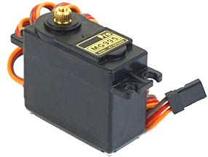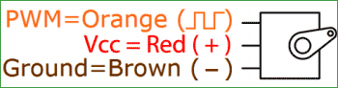

The color coding of your servo motor might differ hence check for your respective datasheet.
All servo motors work directly with your +5V supply rails but we have to be careful on the amount of current the motor would consume if you are planning to use more than two servo motors a proper servo shield should be designed.
Controlling Servo Motor:
All motors have three wires coming out of them. Out of which two will be used for Supply (positive and negative) and one will be used for the signal that is to be sent from the MCU.
Servo motor is controlled by PWM (Pulse with Modulation) which is provided by the control wires. There is a minimum pulse, a maximum pulse and a repetition rate. Servo motor can turn 90 degree from either direction form its neutral position. The servo motor expects to see a pulse every 20 milliseconds (ms) and the length of the pulse will determine how far the motor turns. For example, a 1.5ms pulse will make the motor turn to the 90° position, such as if pulse is shorter than 1.5ms shaft moves to 0° and if it is longer than 1.5ms than it will turn the servo to 180°.
Servo motor works on PWM (Pulse width modulation) principle, means its angle of rotation is controlled by the duration of applied pulse to its Control PIN. Basically servo motor is made up of DC motor which is controlled by a variable resistor (potentiometer) and some gears. High speed force of DC motor is converted into torque by Gears. We know that WORK= FORCE X DISTANCE, in DC motor Force is less and distance (speed) is high and in Servo, force is High and distance is less. The potentiometer is connected to the output shaft of the Servo, to calculate the angle and stop the DC motor on the required angle.
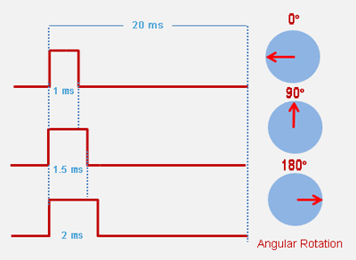
Servo motor can be rotated from 0 to 180 degrees, but it can go up to 210 degrees, depending on the manufacturing. This degree of rotation can be controlled by applying the Electrical Pulse of proper width, to its Control pin. Servo checks the pulse in every 20 milliseconds. The pulse of 1 ms (1 millisecond) width can rotate the servo to 0 degrees, 1.5ms can rotate to 90 degrees (neutral position) and 2 ms pulse can rotate it to 180 degree.
All servo motors work directly with your +5V supply rails but we have to be careful about the amount of current the motor would consume if you are planning to use more than two servo motors a proper servo shield should be designed.

Servo Motor Control with Arduino

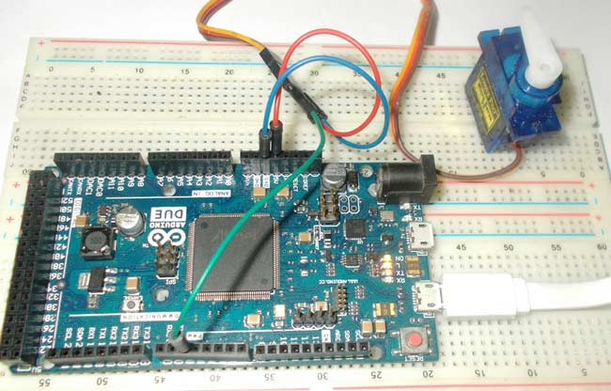
As discussed earlier, Arduino is an ARM controller based board designed for electronic engineers and hobbyists. This DUE board can be used for making CNC machines, 3D printers, robotic arms etc. All these projects have a common feature that is Position Control. Any of these projects needs accuracy towards their position. Accurate positions in these machines can be achieved by Servo Motors. In this session we are going to control the position of a Servo Motor with Arduino

Circuit Diagram and Working Explanation:
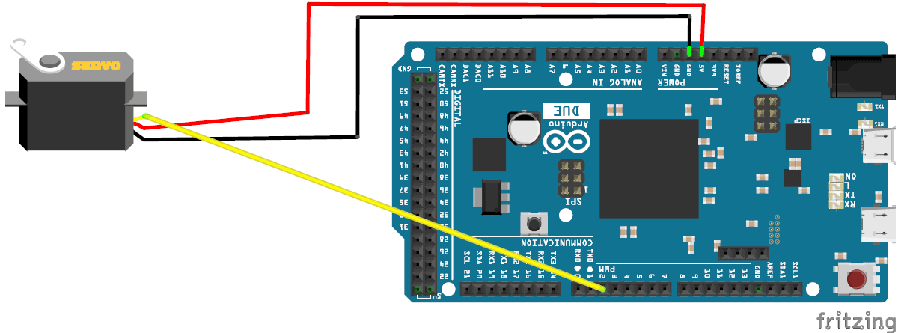
As said earlier in ARDUINO, we have predefined libraries, which will set the frequencies and duty ratios accordingly, once the header file is called or included. In ARDUINO we simply have to state the position of servo that needed and the DUE generates appropriate PWM signal for the servo. The things which we need to do for getting accurate position of servo are,
#include <Servo.h>
Servo myservo;
myservo.attach(servo_signal_pin_attached_to);
myservo.write(needed_position_ angle);
The header file “#include <Servo.h>” includes all the special functions we need, upon calling it we no longer have to worry about the frequency of PWM nor about the DUTY RATIO of signal. With this the user can enter needed position of servo directly without any fuzz.
Secondly a name is to be chosen for the servo by using “Servo myservo”, here myservo is the name chosen, so while writing for position we are going to use this name, this feature comes in handy when we have many servos to control, we can control as many as 12 servos by this.
With the Arduino Due having 12 PWM channels, we need to tell DUE where the signal pin of servo is connected or where it needs to generate the PWM signal. To do this we have “myservo.attach (2);”, here we are telling the DUE that we have connected the signal pin of servo at PIN2.
All left is to set the position, we are going to set the position of servo by using “myservo.write(45);”, by this command the servo hand moves 45 degrees. If we change ‘45’ to ‘175’, the servo axis angles to 175 degrees and stays there. After that, whenever we need to change the position of servo we just need to call the command “myservo.write(needed_position_angle);”.
In the program, we are going to increment and decrement the angles by using loops. So the servo sweeps from 0 to 180, then from 180 to 0 and so on. The Servo Motor Control by Arduino Due is best explained in step by step of C code down below.
Code
#include <Servo.h>

Servo myservo; // providing a name

int angle = 0; // variable to store the servo position

void setup() {
myservo.attach(2); // attaches the servo on pin 2 to the servo object
}

void loop() {
for (angle = 0; angle <= 180; angle += 1) { // goes from 0 degrees to 180 degrees, in steps of 1 degree
myservo.write(angle); // tell servo to go to position in variable 'angle'
delay(15); // waits 15ms for the servo to reach the position
}
for (angle = 180; angle >= 0; angle -= 1) { // goes from 180 degrees to 0 degrees
myservo.write(angle);
delay(15); // waits 15ms for the servo to reach the position
}
}
.

Logic Tech Webcams
A webcam is a video camera that feeds or streams an image or video in real time to or through a computer network, such as the Internet. Webcams are typically small cameras that sit on a desk, attach to a user's monitor, or are built into the hardware. Webcams can be used during a video chat session involving two or more people, with conversations that include live audio and video.
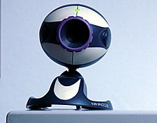
Typical low-cost webcam used with many personal computers (2007)

Higher cost webcam (2017) with 1080p resolution and built-in stereo microphones
Webcam software enables users to record a video or stream the video on the Internet. As video streaming over the Internet requires much bandwidth, such streams usually use compressed formats. The maximum resolution of a webcam is also lower than most handheld video cameras, as higher resolutions would be reduced during transmission. The lower resolution enables webcams to be relatively inexpensive compared to most video cameras, but the effect is adequate for video chat sessions.[1]
The term "webcam" (a clipped compound) may also be used in its original sense of a video camera connected to the Web continuously for an indefinite time, rather than for a particular session, generally supplying a view for anyone who visits its web page over the Internet. Some of them, for example, those used as online traffic cameras, are expensive, rugged professional video cameras.

Webcam
A webcam is a video camera that feeds or streams an image or video in real time to or through a computer network, such as the Internet. Webcams are typically small cameras that sit on a desk, attach to a user's monitor, or are built into the hardware. Webcams can be used during a video chat session involving two or more people, with conversations that include live audio and video.
Typical low-cost webcam used with many personal computers (2007)
Higher cost webcam (2017) with 1080p resolution and built-in stereo microphones
Webcam software enables users to record a video or stream the video on the Internet. As video streaming over the Internet requires much bandwidth, such streams usually use compressed formats. The maximum resolution of a webcam is also lower than most handheld video cameras, as higher resolutions would be reduced during transmission. The lower resolution enables webcams to be relatively inexpensive compared to most video cameras, but the effect is adequate for video chat sessions.[1]
The term "webcam" (a clipped compound) may also be used in its original sense of a video camera connected to the Web continuously for an indefinite time, rather than for a particular session, generally supplying a view for anyone who visits its web page over the Internet. Some of them, for example, those used as online traffic cameras, are expensive, rugged professional video cameras.
Contents

Logic webcam
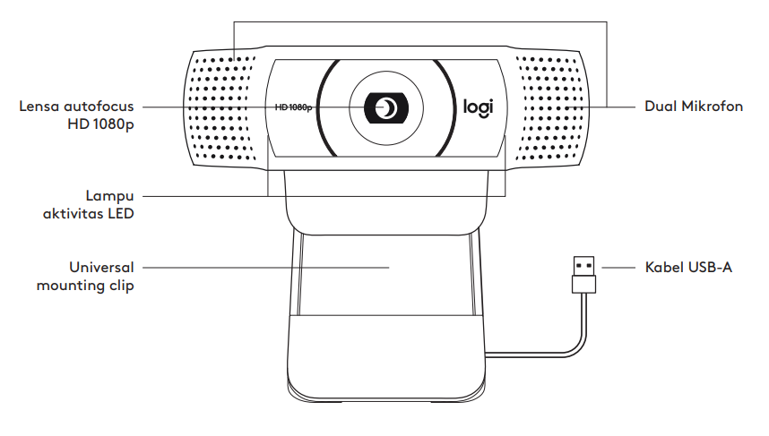Webcam software enables users to record a video or stream the video on the Internet. As video streaming over the Internet requires much bandwidth, such streams usually use compressed formats. The maximum resolution of a webcam is also lower than most handheld video cameras, as higher resolutions would be reduced during transmission.
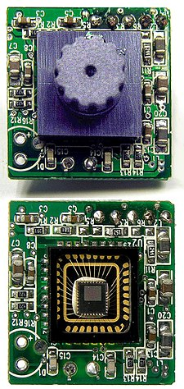
Components of any webcam are: Image sensor, lens and supporting circuitry.
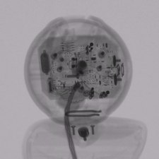Play media
Animated set of X-ray images of a webcam. Images acquired using industrial CT scanning.
Webcams typically include a lens, an image sensor, support electronics, and may also include one or even two microphones for sound.

Image sensor
Main article: Image sensor
Image sensors can be CMOS or CCD, the former being dominant for low-cost cameras, but CCD cameras do not necessarily outperform CMOS-based cameras in the low-price range. Most consumer webcams are capable of providing VGA-resolution video at a frame rate of 30 frames per second. Many newer devices can produce video in multi-megapixel resolutions, and a few can run at high frame rates such as the PlayStation Eye, which can produce 320×240 video at 120 frames per second. The Wii Remote contains an image sensor with a resolution of 1024×768 pixels. Common resolutions of laptops' built-in webcams are 720p (HD), and in lower-end laptops 480p.[2] The earliest known laptops with 1080p (Full HD) webcams like the Samsung 700G7C were released in the early 2010s.[3]
As the bayer filter is proprietary, any webcam contains some built-in image processing, separate from compression.

Optics
Various lenses are available, the most common in consumer-grade webcams being a plastic lens that can be manually moved in and out to focus the camera. Fixed-focus lenses, which have no provision for adjustment, are also available. As a camera system's depth of field is greater for small image formats and is greater for lenses with a large f-number (small aperture), the systems used in webcams have a sufficiently large depth of field that the use of a fixed-focus lens does not impact image sharpness to a great extent.
Most models use simple, focal-free optics (fixed focus, factory-set for the usual distance from the monitor to which it is fastened to the user) or manual focus.
Compression
Digital video streams are represented by huge amounts of data, burdening its transmission (from the image sensor, where the data is continuously created) and storage alike.
Most if not all cheap webcams come with built-in ASIC to do video compression in real-time.
Support electronics read the image from the sensor and transmit it to the host computer. The camera pictured to the right, for example, uses a Sonix SN9C101 to transmit its image over USB. Typically, each frame is transmitted uncompressed in RGB or YUV or compressed as JPEG. Some cameras, such as mobile-phone cameras, use a CMOS sensor with supporting electronics "on die", i.e. the sensor and the support electronics are built on a single silicon chip to save space and manufacturing costs. Most webcams feature built-in microphones to make video calling and videoconferencing more convenient
.
Interface
Typical interfaces used by articles marketed as a "webcam" are USB, Ethernet and IEEE 802.11 (denominated as IP camera). Further interfaces such as e.g. Composite video, S-Video or FireWire were also available.
The USB video device class (UVC) specification allows inter-connectivity of webcams to computers without the need for proprietary device drivers.
Software
Various proprietary as well as free and open-source software is available to handle the UVC stream. One could use Guvcview or GStreamer and GStreamer-based software to handle the UVC stream. Another could use multiple USB cameras attached to the host computer the software resides on, and broadcast multiple streams at once over (Wireless) Ethernet, such as MotionEye. MotionEye can either be installed onto a Raspberry Pi as MotionEyeOs, or afterwards on Raspbian as well. MotionEye can also be set up on Debian, Raspbian is a variant of Debian. Note that MotionEye V4.1.1 ( Aug '21 ) can only run on Debian 10 Buster ( oldstable ) and Python 2.7. Newer versions such as 3.X are not supported at this point of time according to Ccrisan, foundator and author of MotionEye.
CharacteristicsEdit
Webcams are known for their low manufacturing cost and their high flexibility,[4] making them the lowest-cost form of videotelephony. As webcams evolved simultaneously with display technologies, USB interface speeds and broadband internet speeds, the resolution went up from gradually from 320×240, to 640×480, and some now even offer 1280×720 (aka 720p) or 1920×1080 (aka 1080p) resolution.[5][6][7]
Webcams can come with different presets and Fields of View (FOV). Individual users can make use of less than 90° Horizontal FOV for home offices and live streaming. Webcams with as much as 360° Horizontal FOV can be used for small- to medium- sized rooms (sometimes even large rooms). Depending on the users' purposes, webcams in the market can display the whole room or just the general vicinity.
Despite the low cost, the resolution offered as of 2019 is impressive, with now the low-end webcams offering resolutions of 720p, mid-range webcams offering 1080p resolution, and high-end webcams offering 4K resolution at 60 fps.
Webcams have become a source of security and privacy issues, as some built-in webcams can be remotely activated by spyware. To address this concern, many webcams come with a physical lens cover.
Uses
The most popular use of webcams is the establishment of video links, permitting computers to act as videophones or videoconference stations. For example, Apple's iSight camera, which is built into Apple laptops, iMacs and a majority of iPhones, can be used for video chat sessions, using the Messages instant messaging program. Other popular uses include security surveillance, computer vision, video broadcasting, and for recording social videos.
The video streams provided by webcams can be used for a number of purposes, each using appropriate software:
Video monitoringEdit
Webcams may be installed at places such as childcare centres, offices, shops and private areas to monitor security and general activity.
Commerce
Webcams have been used for augmented reality experiences online. One such function has the webcam act as a "magic mirror" to allow an online shopper to view a virtual item on themselves. The Webcam Social Shopper is one example of software that utilizes the webcam in this manner.[8]
Videocalling and videoconferencing
Further information: Videophone, Videoconferencing, and Videotelephony
Webcams can be added to instant messaging, text chat services such as AOL Instant Messenger, and VoIP services such as Skype, one-to-one live video communication over the Internet has now reached millions of mainstream PC users worldwide. Improved video quality has helped webcams encroach on traditional video conferencing systems. New features such as automatic lighting controls, real-time enhancements (retouching, wrinkle smoothing and vertical stretch), automatic face tracking and autofocus, assist users by providing substantial ease-of-use, further increasing the popularity of webcams.
Since the middle of 2020, remote and hybrid work has increased the popularity of webcams. Businesses, schools, and individuals have relied on video conferencing instead of spending on business travel for meetings. Moreover, the number of video conferencing cameras and software have multiplied since then due to their popularity.
Webcam features and performance can vary by program, computer operating system, and also by the computer's processor capabilities. Video calling support has also been added to several popular instant messaging programs.
Video security
Webcams can be used as security cameras. Software is available to allow PC-connected cameras to watch for movement and sound,[9] recording both when they are detected. These recordings can then be saved to the computer, e-mailed, or uploaded to the Internet. In one well-publicised case,[10] a computer e-mailed images of the burglar during the theft of the computer, enabling the owner to give police a clear picture of the burglar's face even after the computer had been stolen.
Unauthorized access of webcams can present significant privacy issues (see "Privacy" section below).
In December 2011, Russia announced that 290,000 Webcams would be installed in 90,000 polling stations to monitor the 2012 Russian presidential election.[11]
Video clips and stillsEdit
Webcams can be used to take video clips and still pictures. Various software tools in wide use can be employed for this, such as PicMaster and Microsoft's Camera app (for use with Windows operating systems), Photo Booth (Mac), or Cheese (with Unix systems). For a more complete list see Comparison of webcam software.
Input control devices
Special software can use the video stream from a webcam to assist or enhance a user's control of applications and games. Video features, including faces, shapes, models and colors can be observed and tracked to produce a corresponding form of control. For example, the position of a single light source can be tracked and used to emulate a mouse pointer, a head-mounted light would enable hands-free computing and would greatly improve computer accessibility. This can be applied to games, providing additional control, improved interactivity and immersiveness.
FreeTrack is a free webcam motion-tracking application for Microsoft Windows that can track a special head-mounted model in up to six degrees of freedom and output data to mouse, keyboard, joystick and FreeTrack-supported games. By removing the IR filter of the webcam, IR LEDs can be used, which has the advantage of being invisible to the naked eye, removing a distraction from the user. TrackIR is a commercial version of this technology.
The EyeToy for the PlayStation 2, PlayStation Eye for the PlayStation 3, and the Xbox Live Vision camera and Kinect motion sensor for the Xbox 360 and are color digital cameras that have been used as control input devices by some games.
Small webcam-based PC games are available as either standalone executables or inside web browser windows using Adobe Flash.
Astro photographyEdit
With very-low-light capability, a few specific models of webcams are very popular to photograph the night sky by astronomers and astro photographers. Mostly, these are manual-focus cameras and contain an old CCD array instead of comparatively newer CMOS array. The lenses of the cameras are removed and then these are attached to telescopes to record images, video, still, or both. In newer techniques, videos of very faint objects are taken for a couple of seconds and then all the frames of the video are "stacked" together to obtain a still image of respectable contrast.
Laser beam profilingEdit
A webcam's CCD response is linear proportional to the incoming light.[12] Therefore, webcams are suitable to record laser beam profiles, after the lens is removed. The resolution of a laser beam profiler depends on the pixel size. Commercial webcams are usually designed to record color images. The size of a webcam's color pixel depends on the model and may lie in the range of 5 to 10 µm. However, a color pixel consists of four black and white pixels each equipped with a color filter (for details see Bayer filter). Although these color filters work well in the visible, they may be rather transparent in the near infrared. By switching a webcam into the Bayer-mode it is possible to access the information of the single pixels and a resolution below 3 µm was possible
Gear Motor
A gear motor is any electric motor coupled with a gear train. Gear motors use either AC (Alternating Current) or DC (Direct Current) power. In most cases, the gear reducer is intended to multiply the available output torque without increasing the power consumption of the motor while maintaining a compact size. The trade off for torque multiplication is a proportional reduction in the speed of the output shaft, and reduced overall efficiency. By utilizing the proper gear technology and ratio for specific applications, the optimal output and speed profiles can be obtained along with the perfect mechanical fit to unlock the maximum value of your OEM equipment
A gearmotor, also called a gear motor or a geared motor, is a combination of a gear system or gearbox and an electric motor. When asking yourself “what is a gear motor” or “what is a geared motor,” you are actually probably wondering how a gearmotor can be useful for your company's products or production facility. Geared motors are efficient because you will only have to mount and operate one system, instead of several. Sometimes inaccurately called “gears motors,” or even geared motors, gearmotors generally combine an efficient motor, such as an Electrically Commutated Motor, with a gear reducer or gearhead. These motor gear combinations are a great way to minimize alignment issues with your motor and its gearbox. You don't need to be worried about separately sourcing gears for motors; instead, you can work with a motor and gear in one: a gear drive motor.

A gear motor develops torque due to hydraulic pressure acting against the area of one tooth. There are two teeth trying to move the rotor in the proper direction, while one net tooth at the center mesh tries to move it in the opposite direction. In the design of a gear motor, one of the gears is keyed to an output shaft, while the other is simply an idler gear. Pressurized oil is sent to the inlet port of the motor.
Most of the gear motors are bidirectional. Reversing the direction of flow can reverse the direction of rotation.As in the case of gear pumps, volumetric displacement is fixed. Due to the high pressure at the inlet and low pressure at the outlet, a large side load on the shaft and bearings is produced. Gear motors are normally limited to 150 bar operating pressures and 2500 RPM operating speed. They are available with a maximum flow capacity of 600 LPM.
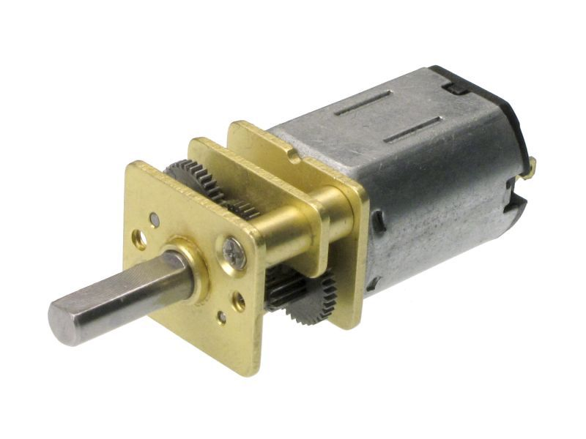The gear motors are simple in construction and have good dirt tolerance, but their efficiencies are lower than those of vane or piston pumps and they leak more than the piston units. Generally,they are not used as servo motors.Hydraulic motors can also be of internal gear design. These types can operate at higher pressures and speeds and also have greater displacements than external gear motors.
DC gear motors are used primarily in automotive applications such as power winches on trucks, windshield wiper motors and power seat or power window motors. Jacks, cranes, lifts, clamping, robotics, conveyance, and mixing are just some of the applications gearmotors are used for in industry.
Right-angle gear motors, which utilize worm, bevel, or hypoid gearing, and inline gear motors, which employ spur gears or planetary gear systems, are the two most prevalent forms of gear motors. Worm, spur, and planetary gear technologies are the most commonly utilized in Gearmotor designs.
Gear motors are offered with a choice of AC or DC motor types and reduction ratios to accommodate a broad range of applications such as automated door operators, food and beverage machines, and robotics

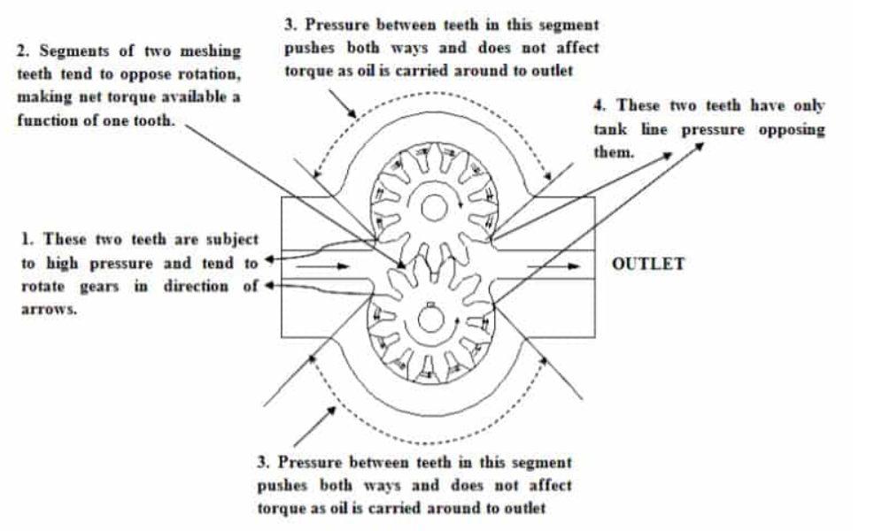
Gear Motor

Types of geared motors
eared motors can be classified based on different elements. The two most common geared motor types are right angle geared motor and inline geared motor.
- Right-angle geared motor use worm, bevel or hypoid gearing.
- Inline geared motor typically use spur gears, helical or planetary gear sets.
- Parallel shaft geared motors type helical gears

Based on the internal disposition, geared motor can be classified as:
- Inline helical geared motors
The helical gear units are coaxial units where the gear unit output shaft is in-line with the motor shaft. The in-line helical motors are mostly used for slow speed/high torque applications.
- Parallel shaft geared motor
This type of geared motor which uses gears to accomplish speed reduction. The motor shaft and the speed reducer shaft are on parallel planes in this specific geared motor.
The Parallel Shaft Geared Motor can use three types of gears to accomplish the transmission.
- Spur Gears are widespread. The teeth on the gear wheel is straight and is parallel to the drive shaft of the speed reducer.
- In Helical gears, the teeth are oblique to the axis of rotation. They transfer greater and power and speed and are relatively more silent and enduring.
- Double helical gears are used to eliminate the axial thrust, the rotation is elicited by the shaft itself.
Applications
- Agitator, Conveyors, Carriage Drives & various material handling equipment.
- Industries– Sugar, Paper, Cement, Pharmaceuticals, Food processing
- Worm or 90-degree gear motor
This is one of the simplest types of geared motor composed of a toothed worm wheel, generally made of bronze with a steel shaft at its centre. The wheel is constantly in contact with the steel screw whose shape looks like that of a worm.
it called a 90-degree motor
The shafts are set up at a 90-degree angle which is one of its main features.
- Bevel Helical geared motors
These types of geared motors are angular geared motors with the output shaft rotated through 90 degrees to the motor shaft. For high output torques, helical geared motor is desirable, as there is a requirement of high density of power of angular geared motor.

Applications
Many industrial gear motors are generally fixed-speed AC-powered devices, while variable-speed fixed-gear-ratio motors offer more control. DC gear motors are most commonly used in vehicle industries such as truck power cranes, windscreen wiper motors, plus power seats or power window motors. On the other hand, gear motors are utilized in a variety of industrial applications, including jacks, cranes, elevators, clamping, automation, transportation, and mixing.
- Packaging, Mixing, Conveyor, Cranes
- Industries- Food Processing, Paper, Sugar, Cement, Material Handling, Pharmaceuticals
Rechargeable battery
A rechargeable battery, storage battery, or secondary cell (formally a type of energy accumulator), is a type of electrical battery which can be charged, discharged into a load, and recharged many times, as opposed to a disposable or primary battery, which is supplied fully charged and discarded after use. It is composed of one or more electrochemical cells. The term "accumulator" is used asit accumulates and stores energy through areversible electrochemical reaction. Rechargeable batteries are produced in many different shapes and sizes, ranging from button cells to megawatt systems connected to stabilize an electrical distribution network. Several different combinations of electrode materials and electrolytes are used, including lead–acid, zinc–air, nickel–cadmium (NiCd), nickel–metal hydride (NiMH), lithium-ion (Li-ion), lithium iron phosphate (LiFePO4), and lithium-ion polymer (Li-ion polymer).
Rechargeable batteries typically initially cost more than disposable batteries, but have a much lower total cost of ownership and environmental impact, as they can be recharged inexpensively many times before they need replacing. Some rechargeable battery types are available in the same sizes and voltages as disposable types, and can be used interchangeably with them.
Billions of dollars in research are being invested around the world for improving batteries and industry also focuses on building better batteries

Charging and discharging
During charging, the positive active material is oxidized, producing electrons, and the negative material is reduced, consuming electrons. These electrons constitute the current flow in the external circuit. The electrolyte may serve as a simple buffer for internal ion flow between the electrodes, as in lithium-ion and nickel-cadmium cells, or it may be an active participant in the electrochemical reaction, as in lead–acid cells.
The energy used to charge rechargeable batteries usually comes from a battery charger using AC mains electricity, although some are equipped to use a vehicle's 12-volt DC power outlet. The voltage of the source must be higher than that of the battery to force current to flow into it, but not too much higher or the battery may be damaged.
Chargers take from a few minutes to several hours to charge a battery. Slow "dumb" chargers without voltage or temperature-sensing capabilities will charge at a low rate, typically taking 14 hours or more to reach a full charge. Rapid chargers can typically charge cells in two to five hours, depending on the model, with the fastest taking as little as fifteen minutes. Fast chargers must have multiple ways of detecting when a cell reaches full charge (change in terminal voltage, temperature, etc.) to stop charging before harmful overcharging or overheating occurs. The fastest chargers often incorporate cooling fans to keep the cells from overheating. Battery packs intended for rapid charging may include a temperature sensor that the charger uses to protect the pack; the sensor will have one or more additional electrical contacts.
Different battery chemistries require different charging schemes. For example, some battery types can be safely recharged from a constant voltage source. Other types need to be charged with a regulated current source that tapers as the battery reaches fully charged voltage. Charging a battery incorrectly can damage a battery; in extreme cases, batteries can overheat, catch fire, or explosively vent their contents
Rate of discharge
Battery charging and discharging rates are often discussed by referencing a "C" rate of current. The C rate is that which would theoretically fully charge or discharge the battery in one hour. For example, trickle charging might be performed at C/20 (or a "20-hour" rate), while typical charging and discharging may occur at C/2 (two hours for full capacity). The available capacity of electrochemical cells varies depending on the discharge rate. Some energy is lost in the internal resistance of cell components (plates, electrolyte, interconnections), and the rate of discharge is limited by the speed at which chemicals in the cell can move about. For lead-acid cells, the relationship between time and discharge rate is described by Peukert's law; a lead-acid cell that can no longer sustain a usable terminal voltage at a high current may still have usable capacity, if discharged at a much lower rate. Data sheets for rechargeable cells often list the discharge capacity on 8-hour or 20-hour or other stated time; cells for uninterruptible power supply systems may be rated at 15-minute discharge.
The terminal voltage of the battery is not constant during charging and discharging. Some types have relatively constant voltage during discharge over much of their capacity. Non-rechargeable alkaline and zinc–carbon cells output 1.5V when new, but this voltage drops with use. Most NiMH AA and AAA cells are rated at 1.2 V, but have a flatter discharge curve than alkalines and can usually be used in equipment designed to use alkaline batteries.
Battery manufacturers' technical notes often refer to voltage per cell (VPC) for the individual cells that make up the battery. For example, to charge a 12 V lead-acid battery (containing 6 cells of 2 V each) at 2.3 VPC requires a voltage of 13.8 V across the battery's terminals
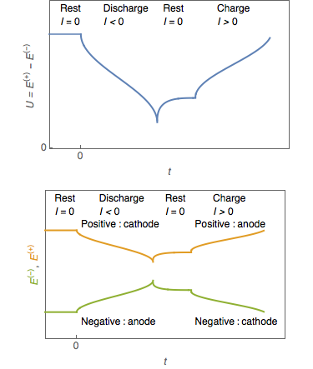
Damage from cell reversal
Subjecting a discharged cell to a current in the direction which tends to discharge it further to the point the positive and negative terminals switch polarity causes a condition called cell reversal. Generally, pushing current through a discharged cell in this way causes undesirable and irreversible chemical reactions to occur, resulting in permanent damage to the cell. Cell reversal can occur under a number of circumstances, the two most common being:
- When a battery or cell is connected to a charging circuit the wrong way around.
- When a battery made of several cells connected in series is deeply discharged.
In the latter case, the problem occurs due to the different cells in a battery having slightly different capacities. When one cell reaches discharge level ahead of the rest, the remaining cells will force the current through the discharged cell.
Many battery-operated devices have a low-voltage cutoff that prevents deep discharges from occurring that might cause cell reversal. A smart battery has voltage monitoring circuitry built inside.
Cell reversal can occur to a weakly charged cell even before it is fully discharged. If the battery drain current is high enough, the cell's internal resistance can create a resistive voltage drop that is greater than the cell's forward emf. This results in the reversal of the cell's polarity while the current is flowing.^{[6][7]} The higher the required discharge rate of a battery, the better matched the cells should be, both in the type of cell and state of charge, in order to reduce the chances of cell reversal.
In some situations, such as when correcting NiCd batteries that have been previously overcharged,^{[8]} it may be desirable to fully discharge a battery. To avoid damage from the cell reversal effect, it is necessary to access each cell separately: each cell is individually discharged by connecting a load clip across the terminals of each cell, thereby avoiding cell reversal.

Damage during storage in fully discharged state
If a multi-cell battery is fully discharged, it will often be damaged due to the cell reversal effect mentioned above. It is possible however to fully discharge a battery without causing cell reversal—either by discharging each cell separately, or by allowing each cell's internal leakage to dissipate its charge over time.
Even if a cell is brought to a fully discharged state without reversal, however, damage may occur over time simply due to remaining in the discharged state. An example of this is the Sulfation that occurs in lead-acid batteries that are left sitting on a shelf for long periods. For this reason it is often recommended to charge a battery that is intended to remain in storage, and to maintain its charge level by periodically recharging it. Since damage may also occur if the battery is overcharged, the optimal level of charge during storage is typically around 30% to 70%.

Depth of discharge
Depth of discharge (DOD) is normally stated as a percentage of the nominal ampere-hour capacity; 0% DOD means no discharge. As the usable capacity of a battery system depends on the rate of discharge and the allowable voltage at the end of discharge, the depth of discharge must be qualified to show the way it is to be measured. Due to variations during manufacture and aging, the DOD for complete discharge can change over time or number of charge cycles. Generally a rechargeable battery system will tolerate more charge/discharge cycles if the DOD is lower on each cycle.^{[9]} Lithium batteries can discharge to about 80 to 90% of their nominal capacity. Lead-acid batteries can discharge to about 50–60%. While flow batteries can discharge 100%.^{[10]}

Lifespan and cycle stability
If batteries are used repeatedly even without mistreatment, they lose capacity as the number of charge cycles increases, until they are eventually considered to have reached the end of their useful life. Different battery systems have differing mechanisms for wearing out. For example, in lead-acid batteries, not all the active material is restored to the plates on each charge/discharge cycle; eventually enough material is lost that the battery capacity is reduced. In lithium-ion types, especially on deep discharge, some reactive lithium metal can be formed on charging, which is no longer available to participate in the next discharge cycle. Sealed batteries may lose moisture from their liquid electrolyte, especially if overcharged or operated at high temperature. This reduces the cycling life.

Recharging time

Recharging time is an important parameter to the user of a product powered by rechargeable batteries. Even if the charging power supply provides enough power to operate the device as well as recharge the battery, the device is attached to an external power supply during the charging time. For electric vehicles used industrially, charging during off-shifts may be acceptable. For highway electric vehicles, rapid charging is necessary for charging in a reasonable time.
A rechargeable battery cannot be recharged at an arbitrarily high rate. The internal resistance of the battery will produce heat, and excessive temperature rise will damage or destroy a battery. For some types, the maximum charging rate will be limited by the speed at which active material can diffuse through a liquid electrolyte. High charging rates may produce excess gas in a battery, or may result in damaging side reactions that permanently lower the battery capacity. Very roughly, and with many exceptions and caveats, restoring a battery's full capacity in one hour or less is considered fast charging. A battery charger system will include more complex control-circuit- and charging strategies for fast charging, than for a charger designed for slower recharging.
Active component
The active components in a secondary cell are the chemicals that make up the positive and negative active materials, and the electrolyte. The positive and negative electrodes are made up of different materials, with the positive exhibiting a reduction potential and the negative having an oxidation potential. The sum of the potentials from these half-reactions is the standard cell potential or voltage.
In primary cells the positive and negative electrodes are known as the cathode and anode, respectively. Although this convention is sometimes carried through to rechargeable systems—especially with lithium-ion cells, because of their origins in primary lithium cells—this practice can lead to confusion. In rechargeable cells the positive electrode is the cathode on discharge and the anode on charge, and vice versa for the negative electrode.
Types
See also: List of battery types and Comparison of commercial battery types
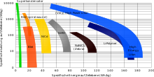
Ragone plot of common types

Commercial types
The lead–acid battery, invented in 1859 by French physicist Gaston Planté, is the oldest type of rechargeable battery. Despite having a very low energy-to-weight ratio and a low energy-to-volume ratio, its ability to supply high surge currents means that the cells have a relatively large power-to-weight ratio. These features, along with the low cost, makes it attractive for use in motor vehicles to provide the high current required by automobile starter motors.
The nickel–cadmium battery (NiCd) was invented by Waldemar Jungner of Sweden in 1899. It uses nickel oxide hydroxide and metallic cadmium as electrodes. Cadmium is a toxic element, and was banned for most uses by the European Union in 2004. Nickel–cadmium batteries have been almost completely superseded by nickel–metal hydride (NiMH) batteries.
The nickel–iron battery (NiFe) was also developed by Waldemar Jungner in 1899; and commercialized by Thomas Edison in 1901 in the United States for electric vehicles and railway signalling. It is composed of only non-toxic elements, unlike many kinds of batteries that contain toxic mercury, cadmium, or lead.
The nickel–metal hydride battery (NiMH) became available in 1989.^{[11]} These are now a common consumer and industrial type. The battery has a hydrogen-absorbing alloy for the negative electrode instead of cadmium.
The lithium-ion battery was introduced in the market in 1991, is the choice in most consumer electronics, having the best energy density and a very slow loss of charge when not in use. It does have drawbacks too, particularly the risk of unexpected ignition from the heat generated by the battery.^{[12]} Such incidents are rare and according to experts, they can be minimized "via appropriate design, installation, procedures and layers of safeguards" so the risk is acceptable.
Lithium-ion polymer batteries (LiPo) are light in weight, offer slightly higher energy density than Li-ion at slightly higher cost, and can be made in any shape. They are available^{[14]} but have not displaced Li-ion in the market.^{[15]} A primary use is for LiPo batteries is in powering remote-controlled cars, boats and airplanes. LiPo packs are readily available on the consumer market, in various configurations, up to 44.4v, for powering certain R/C vehicles and helicopters or drones. Some test reports warn of the risk of fire when the batteries are not used in accordance with the instructions.^{[18]} Independent reviews of the technology discuss the risk of fire and explosion from Lithium-ion batteries under certain conditions because they use liquid electrolytes.
A rechargeable battery is only one of several types of rechargeable energy storage systems.Several alternatives to rechargeable batteries exist or are under development. For uses such as portable radios, rechargeable batteries may be replaced by clockwork mechanisms which are wound up by hand, driving dynamos, although this system may be used to charge a battery rather than to operate the radio directly. Flashlights may be driven by a dynamo directly. For transportation, uninterruptible power supply systems and laboratories, flywheel energy storage systems store energy in a spinning rotor for conversion to electric power when needed; such systems may be used to provide large pulses of power that would otherwise be objectionable on a common electrical grid.
Ultracapacitors – capacitors of extremely high value – are also used; an electric screwdriver which charges in 90 seconds and will drive about half as many screws as a device using a rechargeable battery was introduced in 2007,^{[43]} and similar flashlights have been produced. In keeping with the concept of ultracapacitors, betavoltaic batteries may be utilized as a method of providing a trickle-charge to a secondary battery, greatly extending the life and energy capacity of the battery system being employed; this type of arrangement is often referred to as a "hybrid betavoltaic power source" by those in the industry.^{[44]}
Ultracapacitors are being developed for transportation, using a large capacitor to store energy instead of the rechargeable battery banks used in hybrid vehicles. One drawback of capacitors compared to batteries is that the terminal voltage drops rapidly; a capacitor that has 25% of its initial energy left in it will have one-half of its initial voltage. By contrast, battery systems tend to have a terminal voltage that does not decline rapidly until nearly exhausted. This terminal voltage drop complicates the design of power electronics for use with ultracapacitors. However, there are potential benefits in cycle efficiency, lifetime, and weight compared with rechargeable systems. China started using ultracapacitors on two commercial bus routes in 2006; one of them is route 11 in Shanghai.^{[45]}
Flow batteries, used for specialized applications, are recharged by replacing the electrolyte liquid. A flow battery can be considered to be a type of rechargeable fuel cell.
Applications
Devices which use rechargeable batteries include automobile starters, portable consumer devices, light vehicles (such as motorized wheelchairs, golf carts, electric bicycles, and electric forklifts), road vehicles (cars, vans, trucks, motorbikes), trains, small airplanes, tools, uninterruptible power supplies, and battery storage power stations. Emerging applications in hybrid internal combustion-battery and electric vehicles drive the technology to reduce cost, weight, and size, and increase lifetime.
Older rechargeable batteries self-discharge relatively rapidly, and require charging before first use; some newer low self-discharge NiMH batteries hold their charge for many months, and are typically sold factory-charged to about 70% of their rated capacity.
Battery storage power stations use rechargeable batteries for load-leveling (storing electric energy at times of low demand for use during peak periods) and for renewable energy uses (such as storing power generated from photovoltaic arrays during the day to be used at night). Load-leveling reduces the maximum power which a plant must be able to generate, reducing capital cost and the need for peaking power plants.
According to a report from Research and Markets, the analysts forecast the global rechargeable battery market to grow at a CAGR of 8.32% during the period 2018–2022.
Small rechargeable batteries can power portable electronic devices, power tools, appliances, and so on. Heavy-duty batteries power electric vehicles, ranging from scooters to locomotives and ships. They are used in distributed electricity generation and in stand-alone power systems.

Usb
Universal Serial Bus (USB) is an industry standard that establishes specifications for cables, connectors and protocols for connection, communication and power supply (interfacing) between computers, peripherals and other computers.^{[2]} A broad variety of USB hardware exists, including 14 different connector types, of which USB-C is the most recent.
First released in 1996, the USB standards are maintained by the USB Implementers Forum (USB-IF). The four generations of USB are: USB 1.x, USB 2.0, USB 3.x, and USB4

Available connectors by USB standard
Standard | USB 1.0  1996 | USB 1.1  1998 | USB 2.0  2001 | USB 2.0  Revised | USB 3.0  2008 | USB 3.1  2013 | USB 3.2  2017 | USB4  2019
Maximum transfer rate | 12 Mbps |  | 480 Mbps |  | 5 Gbps | 10 Gbps | 20 Gbps | 40 Gbps
Type A connector | 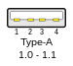 |  | 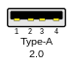 |  | 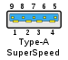 |  | Deprecated
Type B connector | 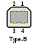 |  |  |  | 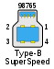 |  | Deprecated
Type C connector | N/A |  |  | 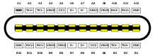  USB-C (Enlarged)
Mini-A connector | N/A | 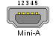 |  |  | Deprecated
Mini-B connector | N/A | 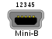 |  |  | Deprecated
Mini-AB connector | N/A |  |  | 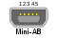 | Deprecated
Micro-A connector | N/A |  |  | 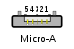 | 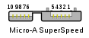 |  | Deprecated
Micro-B connector | N/A |  |  | 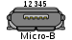 | 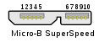 |  | Deprecated
Micro-AB connector | N/A |  |  | 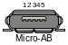 | 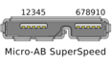 |  | Deprecated
- The USB interface is self-configuring, eliminating the need for the user to adjust the device's settings for speed or data format, or configure interrupts, input/output addresses, or direct memory access channels.^{[5]}
- USB connectors are standardized at the host, so any peripheral can use most available receptacles.
- USB takes full advantage of the additional processing power that can be economically put into peripheral devices so that they can manage themselves. As such, USB devices often do not have user-adjustable interface settings.
- The USB interface is hot-swappable (devices can be exchanged without rebooting the host computer).
- Small devices can be powered directly from the USB interface, eliminating the need for additional power supply cables.
- Because use of the USB logo is only permitted after compliance testing, the user can have confidence that a USB device will work as expected without extensive interaction with settings and configuration.
- The USB interface defines protocols for recovery from common errors, improving reliability over previous interfaces.^{[4]}

USB 2.0

The Hi-Speed USB logo
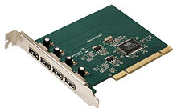
A USB 2.0 PCI expansion card
USB 2.0 was released in April 2000, adding a higher maximum signaling rate of 480 Mbit/s (maximum theoretical data throughput 53 MByte/s^{[19]}) named High Speed or High Bandwidth, in addition to the USB 1.x Full Speed signaling rate of 12 Mbit/s (maximum theoretical data throughput 1.2 MByte/s^{[20]}).
Modifications to the USB specification have been made via engineering change notices (ECNs). The most important of these ECNs are included into the USB 2.0 specification package available from USB.org:^{[21]}
- Mini-A and Mini-B Connector
- Micro-USB Cables and Connectors Specification 1.01
- InterChip USB Supplement
- On-The-Go Supplement 1.3 USB On-The-Go makes it possible for two USB devices to communicate with each other without requiring a separate USB host
- Battery Charging Specification 1.1 Added support for dedicated chargers, host chargers behaviour for devices with dead batteries
- Battery Charging Specification 1.2:^{[22]} with increased current of 1.5 A on charging ports for unconfigured devices, allowing High Speed communication while having a current up to 1.5 A
- Link Power Management Addendum ECN, which adds a sleep power state
- USB 2.0 VBUS Max Limit, increased the maximum allowable V_BUS voltage from 5.25V to 5.50V to align with the USB Type-C Spec, which was released simultaneously.
- ice that relies on the USB standard requires minimal operator action. When a user plugs a device into a port on a running computer, it either entirely automatically configures using existing device drivers, or the system prompts the user to locate a driver, which it then installs and configures automatically.
The USB standard also provides multiple benefits for hardware manufacturers and software developers, specifically in the relative ease of implementation:
- The USB standard eliminates the requirement to develop proprietary interfaces to new peripherals.
- The wide range of transfer speeds available from a USB interface suits devices ranging from keyboards and mice up to streaming video interfaces.
- A USB interface can be designed to provide the best available latency for time-critical functions or can be set up to do background transfers of bulk data with little impact on system resources.
- The USB interface is generalized with no signal lines dedicated to only one function of one device

